

SPREADSHEET PROJECT:
Zomato Operational Analytics System

Submitted By – Ashish Kumar
Submission Date – 01/03/2026

Objective Questions

Question – 1 What is the total no. of tables present in the data?
Answer:-
There are two tables present in data provided
- Raw Data of Zomato.
- Country Description.
Image is provided below:
Final Answer:
There are two tables present in the provided dataset:
- Raw Data of Zomato
- Country Description

Approach:
- Reviewed the dataset structure in the Excel file.
- Identified the distinct structured data ranges formatted as tables.
- Observed that one table contains detailed restaurant-level information (Zomato raw data), and the other contains country-related reference information (Country Description).
- Counted the total number of structured tables present.

Question – 2 What is the total no. of attributes present in the data?
Answer:-
There are 24 attributes (Columns) Present in the data provided.
Final Answer:
There are 24 attributes (columns) present in the provided dataset.
Approach:
- Opened the dataset and examined the header row of the main data table.
- Counted the total number of column headings representing individual attributes.
- Verified that each column corresponds to a unique field (such as Restaurant ID, Restaurant Name, Country Code, City, Cuisines, Ratings, Votes, etc.).
- The total count of distinct column headers equals 24.

Question – 3 How many categorical columns are there in the data?
Answer:-
There are 10 categorical columns in the raw data found using COUNTIF function ‘=COUNTA(UNIQUE(range))’ on each column individually.
Final Answer: There are 10 categorical columns in the raw dataset.

Serial no. | Column Name
1 | City
2 | Restaurant Name
3 | Country
4 | Cuisines
5 | Has online delivery
6 | Switch to order menu
7 | Is delivering now
8 | locality
9 | currency
10 | Has table booking
Approach
- Examined each column in the raw dataset individually.
- Used the formula =COUNTA(UNIQUE(range)) to determine the uniqueness and nature of values in each column.
- Columns containing non-numeric, descriptive, or label-based values were classified as categorical.
- After evaluating all columns, a total of 10 columns were identified as categorical variables.

Question – 4 The dataset contained inconsistent and missing values, so it was cleaned before proceeding with further analysis.
Answer:-
The following methods were used to handle data inconsistencies and missing values:
Approach :-
a) Used the Filter function to identify missing data.
b) Applied filters to each column and searched for Blank values.
c) Missing values were found in the “Cuisines” column.
Since all blank entries belonged to the country United States of America, and after reviewing the existing data it was observed that Mexican cuisine appeared most frequently, the following formula was used to fill the blank values:
=IF(I2="","Mexican",I2)
d) To improve consistency, the year was extracted from the Date of Opening column for better analysis using the formula:
=YEAR(X2)
e) Ensured there were no duplicate records by using the Remove Duplicates feature.
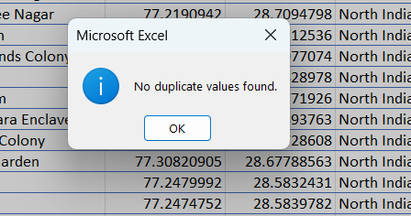
f) Hid unnecessary columns and removed unwanted columns (Column E and Column G).
g) Currency Conversion to INR:
Final Answer:
The dataset was thoroughly cleaned to handle inconsistencies and missing values before performing further analysis. Missing entries were treated, formats were standardized, duplicates were removed, unnecessary columns were excluded, and currency values were converted into INR for uniform comparison.

- The dataset included restaurants from multiple countries with different currencies. To enable proper cost comparison, all values were converted to Indian Rupee (INR).
- The Average Cost for Two was converted into INR for consistent comparison in charts and analysis.
- Two helper columns were added: one for the Rate to INR and another for the calculated Average Cost for Two in INR.
- A separate reference table titled “Summary Currency” was created to store currency conversion rates.
h) Modified the date format to make it clear and consistent, as the original format was not easily understandable.

Question – 5 Using lookup functions, the country names were filled in the original dataset based on the country code.
Answer:-
For country-wise analysis, the Country column was required in the raw dataset. Therefore, a new column (Column D) named Country was created and populated using the VLOOKUP function.
Final Answer:
The Country names were successfully populated in the original dataset by using the VLOOKUP function based on the available Country Code. A new column titled Country (Column D) was created in the raw dataset, and the respective country names were fetched from the “Country Description” worksheet.

Approach:
- The raw dataset contained a Country Code column but did not include country names.
- A separate worksheet named “Country Description” stored the mapping between Country Code (Column A) and Country Name (Column B).
- To enable country-wise analysis, a new column (Column D) named Country was inserted in the raw dataset.
- The VLOOKUP function was applied to retrieve the corresponding country name for each country code.

The country code was available in the raw data sheet, and the corresponding country names were stored in another worksheet titled “Country Description.”
The formula used was:
=VLOOKUP(C2,'Country Description'!$A$1:$B$16,2,0)

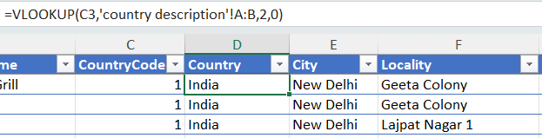

Question – 6 Create a table to represent the number of restaurants opened in each country.
Answer:-
To determine the number of restaurants opened in each country, I created a Pivot Table in the worksheet titled “Objective Q - 6” in the Excel file.
- The Country field was placed in the Rows section.
- The RestaurantID field was added to the Values section and set to Count to calculate the total number of restaurants in each country.
Additionally, a Pivot Chart was created to visually represent the data.
Visualization Technique Used: Line Chart
The image is taken from the “Objective Q - 6” worksheet in the Excel file.
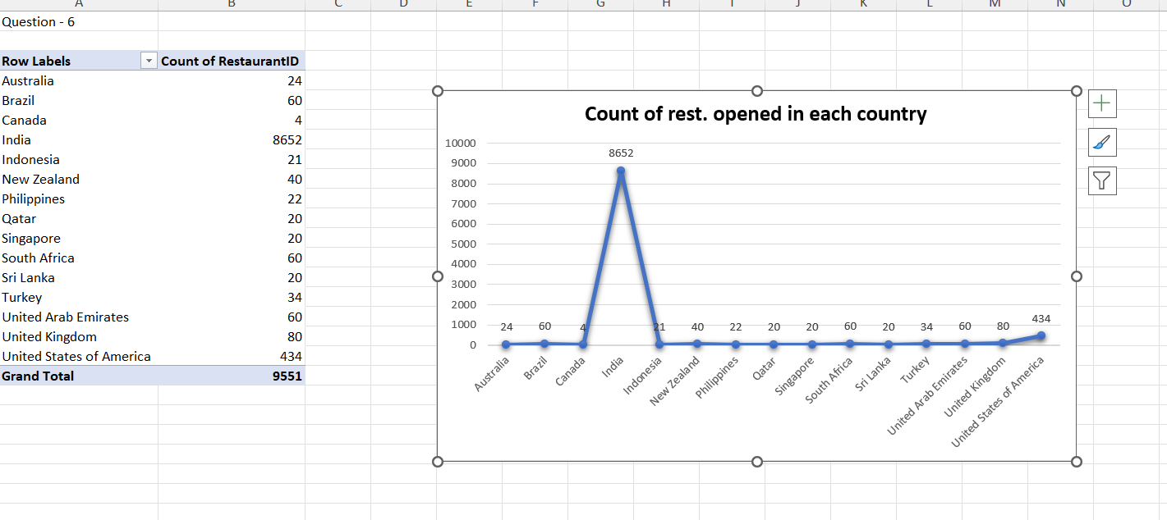
Final Answer:
A table was created to represent the total number of restaurants opened in each country using a Pivot Table. The table displays each country along with the corresponding count of restaurants operating in that country.

Approach:
- The analysis was performed in the worksheet titled “Objective Q - 6” in the Excel file.
- A Pivot Table was created from the raw dataset.
- The Country field was placed in the Rows section to list all countries.
- The RestaurantID field was added to the Values section.
- The Value Field Settings were configured to Count (Count of RestaurantID) to calculate the total number of restaurants in each country.
This method ensures accurate aggregation of restaurant counts country-wise.

Charts & Tables (if any):
- Table / Chart Name: Country-wise Restaurant Count (Pivot Table)
- Description:
The Pivot Table displays the total number of restaurants opened in each country based on the count of RestaurantID.
- Table / Chart Name: Country-wise Restaurant Count (Pivot Chart – Line Chart)
- Description:
A Line Chart was created to visually represent the number of restaurants across different countries, making comparison and trend identification easier.

Question – 7 Also, the management wants to look at the number of restaurants opened each year, so provide them with something here.
Answer:-
To analyze the number of restaurants opened each year, I created another Pivot Table in the worksheet titled “Objective Q – 7” in the Excel file.
- The Year field was placed in the Rows section.
- The RestaurantID field was added to the Values section and set to Count to calculate the total number of restaurants opened annually.
A Pivot Chart was also generated to present the yearly trend visually.
Visualization Technique Used: Column Chart
The image is taken from the “Objective Q - 7” worksheet in the Excel file.
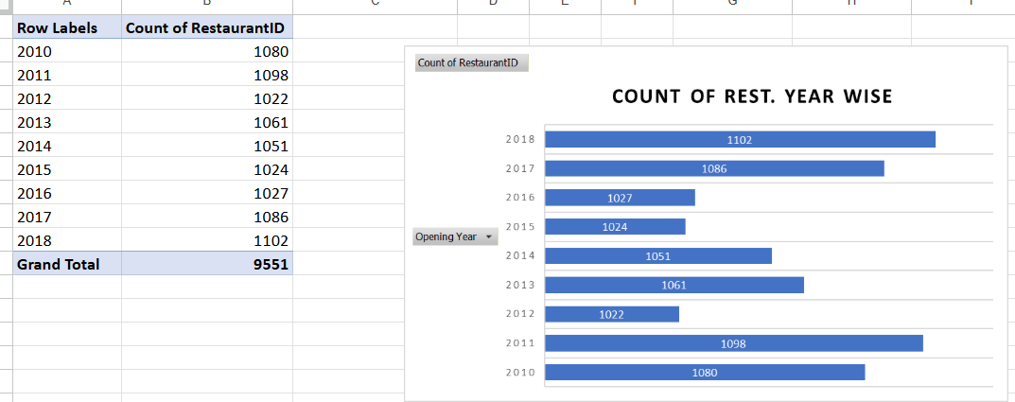
Final Answer:
A year-wise summary table was created to show the number of restaurants opened each year. The table presents the total count of restaurants opened annually, helping management understand yearly growth and expansion trends.

Approach:
- The analysis was performed in the worksheet titled “Objective Q – 7” in the Excel file.
- A Pivot Table was created from the raw dataset.
- The Year field was placed in the Rows section to display each year separately.
- The RestaurantID field was added to the Values section.
- The Value Field Settings were set to Count (Count of RestaurantID) to calculate the total number of restaurants opened in each year.
This approach ensures accurate year-wise aggregation and helps in identifying trends over time.

Charts & Tables (if any):
- Table / Chart Name: Year-wise Restaurant Opening Count (Pivot Table)
- Description:
The Pivot Table shows the total number of restaurants opened each year based on the count of RestaurantID.
- Table / Chart Name: Year-wise Restaurant Opening Trend (Pivot Chart – Column Chart)
- Description:
A Column Chart was created to visually represent the yearly trend of restaurant openings, making it easier to analyze growth patterns and compare performance across different years.

Question – 8 What is the total number of restaurants in India in the price range of 4?
Answer:-
The total number of restaurants in India within the price range of 4 was calculated in the worksheet titled “Objective Q - 8” in the Excel file using the COUNTIFS function on the raw data provided.
Formula used:
=COUNTIFS('Raw Data'!D:D,"India",'Raw Data'!Q:Q,4)
Additionally, the total number of restaurants in India with a price range above 4 has also been calculated and is displayed below.
The image is taken from the “Objective Q - 8” worksheet in the Excel file.

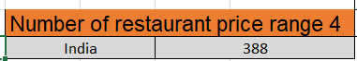
Final Answer:
The total number of restaurants in India within the price range of 4 was calculated using the COUNTIFS function from the raw dataset. The result represents all restaurants located in India that fall exactly under price range category 4.
Additionally, the total number of restaurants in India with a price range above 4 was also calculated for comparison and displayed in the worksheet.

Approach:
- The analysis was performed in the worksheet titled “Objective Q - 8” in the Excel file.
- The COUNTIFS function was used to apply multiple criteria on the raw dataset.
- Two conditions were applied:
  - Country must be India.
  - Price Range must be 4.
Logic of the Formula:
- 'Raw Data'!D:D,"India" → Filters records where the Country is India.
- 'Raw Data'!Q:Q,4 → Filters records where the Price Range equals 4.
- The function counts only those rows that satisfy both conditions simultaneously.
A similar COUNTIFS formula was used to calculate restaurants with a price range greater than 4.

Charts & Tables (if any):
- Table / Chart Name: India Price Range Analysis
- Description:
This table displays the total number of restaurants in India under price range 4 and those above price range 4, enabling comparison of pricing distribution within the country.

Question – 9 What is the average number of voters for the restaurants in each country according to the data.
Answer:-
The average voter count for each country was analyzed using a Pivot Table created in the worksheet titled “Objective Q - 9” in the Excel file, as shown below.
A Pivot Chart was also generated to visually present the comparison across countries.

Visualization Technique Used: Column Chart
The image is taken from the “Objective Q - 9” worksheet in the Excel file.
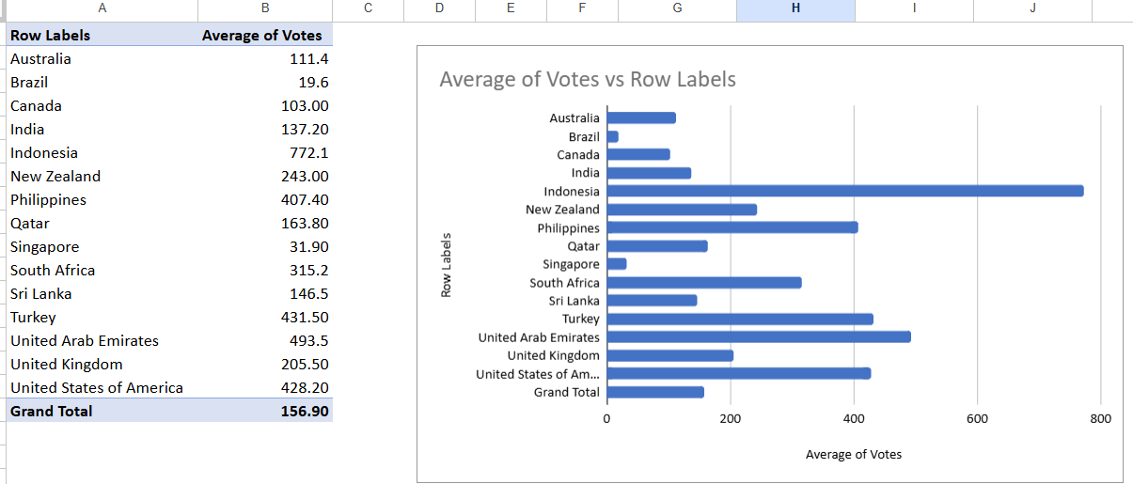
Final Answer:
The average number of voters for restaurants in each country was calculated and presented in a summary table. The results show the mean voter count country-wise, enabling comparison of customer engagement levels across different countries.

Approach:
- The analysis was conducted in the worksheet titled “Objective Question 9” in the Excel file.
- A Pivot Table was created from the raw dataset.
- The Country field was placed in the Rows section to list all countries.
- The Votes (Voter Count) field was added to the Values section.
- The Value Field Settings were changed to Average (instead of Sum or Count) to calculate the mean number of voters for restaurants in each country.
This approach ensures accurate aggregation and meaningful comparison of average voter engagement across countries.

Charts & Tables (if any):
- Table / Chart Name: Country-wise Average Voter Count (Pivot Table)
- Description:
The Pivot Table displays the average number of voters per restaurant for each country.
- Table / Chart Name: Country-wise Average Voter Comparison (Pivot Chart – Column Chart)
- Description:
A Column Chart was created to visually compare the average voter count across countries, making it easier to identify variations in customer participation levels.

Question – 10 Calculate the average rating for all the restaurants that have price range < 4 and provide online delivery. Use only the “IF” function, Logical Operators, and Aggregation functions to solve this problem. [Note: Don’t use Conditional aggregation in this question.]
Answer:-
In this question, conditional aggregation was not allowed, so I used the IF function along with logical operators to meet the criteria specified in the question. The AVERAGE function was then applied to calculate the average ratings for both of the given criteria. The formulas used for this evaluation are mentioned below:
=AVERAGE(IF(('Raw Data'!Q:Q<4)*('Raw Data'!N:N="Yes"),'Raw Data'!T:T))

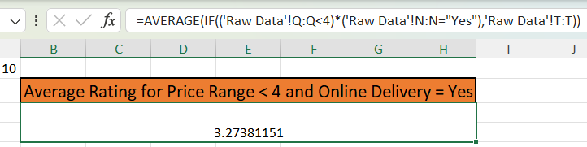

From ‘Objective Questions’ Worksheet in Excel Sheet
Final Answer:
The average rating for all restaurants with a price range less than 4 and online delivery available (Yes) was calculated using the IF function combined with logical operators and the AVERAGE aggregation function. The result reflects the mean rating of only those restaurants that satisfy both specified conditions.

Approach:
- As conditional aggregation (such as AVERAGEIFS) was not allowed, the solution was built using the IF function, logical operators, and the AVERAGE function.
- Two conditions were applied:
  - Price Range < 4
  - Online Delivery = "Yes"
- Logical multiplication * was used to combine both conditions, ensuring that only rows meeting both criteria simultaneously were evaluated.
- The IF function filtered ratings based on these conditions.
- The AVERAGE function calculated the mean of the filtered ratings.
Logic of the Formula:
- 'Raw Data'!Q:Q<4 → Checks for restaurants with price range less than 4.
- 'Raw Data'!N:N="Yes" → Checks whether online delivery is available.
- * → Ensures both logical conditions are TRUE (acts as AND).
- 'Raw Data'!T:T → Returns the Rating column values for qualifying rows.
- AVERAGE → Computes the average of the filtered ratings.

Charts & Tables (if any):
- Table / Chart Name: Conditional Average Rating Analysis
- Description:
Displays the calculated average rating for restaurants meeting both conditions (Price Range < 4 and Online Delivery = Yes), derived using logical filtering within the IF function.

Question – 11 Using Conditional formatting highlight the rows of restaurants that are located in the countries or cities that you’ve suggested to the management for opening new restaurants.
Answer:- Two key factors were considered while recommending countries or cities for opening new restaurants:
a) The total number of restaurants in each country.
b) The average rating of restaurants in each country.
c) Based on this analysis, Australia, Canada, Sri Lanka, Singapore, and Brazil are suggested as suitable countries for opening new restaurants.
d) These countries were selected because a higher number of restaurant occurrences indicates strong market presence and popularity. Additionally, the average rating of 3.5 or above reflects positive customer feedback and overall satisfaction.
e) To evaluate these criteria, three new columns — “Count of Restaurants” and “Average of Ratings” “New Open Restaurant” — were created in the worksheet named

‘Q – 11 Objective’.
The formulas used are mentioned below:
=COUNTIFS(B:B,B735)

And =AVERAGEIFS(U:U,B:B,B735)
Conditional Formatting Rule Used:
=AND(OR(D735="Australia", D735="Canada", D735="Singapore", D735="Brazil", D735="Sri Lanka"), Z735 >1 , AA735>=3.5)
Final Answer:
The rows of restaurants located in the recommended countries — Australia, Canada, Sri Lanka, Singapore, and Brazil — were successfully highlighted using Conditional Formatting.
These countries were identified as suitable for opening new restaurants based on restaurant count and average rating analysis.

Approach:
- Two key evaluation criteria were considered:
a) Total number of restaurants in each country.
b) Average rating of restaurants in each country.
- Countries with higher restaurant counts indicate strong market presence and demand.
- Countries with an average rating of 3.5 or above reflect positive customer feedback and satisfaction.
- Based on this combined analysis, the five countries listed above were recommended.
To support this evaluation:
- Three additional columns were created in the worksheet:
  - Count of Restaurants
  - Average of Ratings
  - New Open Restaurant (Recommendation Indicator)
- Conditional Formatting was applied using a formula rule to highlight entire rows where the Country column matched any of the suggested countries.
- The rule was applied across the dataset to visually distinguish recommended locations for expansion.

Charts & Tables (if any):
- Table / Chart Name: Country Recommendation Analysis Table
- Description:
This table contains country-wise restaurant counts, average ratings, and a recommendation indicator column used to determine suitable countries for expansion.
- Table / Chart Name: Conditional Formatting Highlighted Dataset
- Description:
The dataset with highlighted rows visually marks restaurants located in the recommended countries, making them easily identifiable for management review.

Question – 12 Create a new customized price column that consists of the abbreviation/symbol of the currency along with the Average_cost_for_two value. [Use string operations to do this task]
Answer:-
• Created a table in the ‘LOOKUP Currency’ worksheet that contains the list of currencies along with their respective symbols.
• Added a new column named ‘Currency Symbol’ in the raw data sheet to fetch the appropriate symbol using the VLOOKUP function from the table available in the ‘LOOKUP Currency’ worksheet.
• Further, created a ‘Customized Price’ column where the price is combined with the respective currency symbol using the CONCAT function, as required in the question.
Approach:
- A reference table was created in the worksheet titled “LOOKUP Currency”, containing:
  - Currency Name
  - Corresponding Currency Symbol
- In the Raw Data sheet:
  - A new column named “Currency Symbol” was added.
  - The VLOOKUP function was used to fetch the correct currency symbol from the LOOKUP Currency table based on the currency field available in the raw dataset.
Formula Used (To Fetch Currency Symbol):
=VLOOKUP('Raw Data'!K3,'LOOKUP Currency'!$A$1:$B$13,2,0)
- After retrieving the symbol, another column named “Customised Price” was created.
- The CONCAT function was used to combine the Currency Symbol and the Average_cost_for_two value with a space in between.
Formula Used (To Create Customized Price):
=CONCAT(U2," ",S2)
Logic of the Formula:
- U2 → Refers to the Currency Symbol column.
- " " → Adds a space between the symbol and the value.
- S2 → Refers to the Average_cost_for_two column.
- CONCAT → Joins both text and numeric values into a single formatted string.
The formula was then dragged down to apply it to all rows in the dataset.

Charts & Tables (if any):
- Table / Chart Name: Currency Lookup Table
- Description:
Contains currency names and their corresponding symbols used as a reference for the VLOOKUP function.
- Table / Chart Name: Customized Price Column
- Description:
Displays the final combined output of Currency Symbol and Average_cost_for_two values, formatted as a single text string for better readability and reporting.

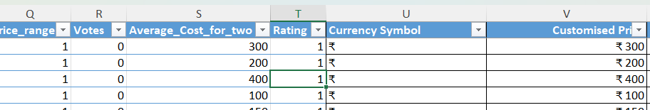
Question – 13 How can you create an array formula in Excel or Google Sheets to count the number of restaurants listed that do not offer online delivery, are in the lowest price range, and have an average cost for two people less than or equal to 250 Indian Rupees?
Answer:- We have three conditions given
- ‘No’ online delivery
- ‘Lowest’ price range (price range = 1)
Average cost for two ‘≤ 250 INR’
for counting number of restaurants depending on these using Array Formula.
Note: The array formula used in this analysis works by applying multiplication as the main filtering technique. Instead of directly counting records based on criteria, it calculates a product for each row.
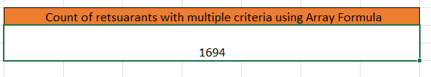
Using Array Formula (Ctrl + Shift + Enter.)
Final Answer:
The total number of restaurants that:
- Do not offer online delivery,
- Belong to the lowest price range (Price Range = 1), and
- Have an average cost for two ≤ 250 INR,
was calculated using an Array Formula that applies logical conditions and multiplication-based filtering.

Approach:
Three conditions were applied simultaneously:
a) Online Delivery = "No"
b) Price Range = 1 (Lowest price range)
c) Average Cost for Two ≤ 250
Instead of using COUNTIFS, an Array Formula was created using logical comparisons and multiplication (*) to combine conditions.
Array Formula (Excel – Confirm using Ctrl + Shift + Enter in older versions):
=SUM(('Raw Data'!N2:N9552="No")*
('Raw Data'!Q2:Q9552=MIN('Raw Data'!Q2:Q9552))*
('Raw Data'!Y2:Y9552<=250))
(In Google Sheets or newer Excel versions, simply press Enter as dynamic arrays are supported.)

Logic Behind the Formula:
- 'Raw Data'!N2:N9552="No" → Checks restaurants that do not provide online delivery.
- 'Raw Data'!Q2:Q9552=MIN('Raw Data'!Q2:Q9552) → Ensures only the lowest price range (Price Range = 1) is considered.
- 'Raw Data'!Y2:Y9552<=250 → Filters restaurants where the average cost for two is less than or equal to 250 INR.
- * (Multiplication Operator) → Works as a logical AND condition.
The formula works row-by-row:
- If all conditions are TRUE → 1 × 1 × 1 = 1
- If any condition is FALSE → result becomes 0
The SUM function then adds all the 1’s, giving the final count of restaurants that meet all criteria.

Charts & Tables (if any):
- Table / Chart Name: Conditional Restaurant Count (Array Formula Result)
- Description:
Displays the total number of restaurants satisfying all three specified conditions using a multiplication-based array filtering approach.

Note: The array formula applied here uses multiplication as the core filtering method. Rather than directly counting records based on specific conditions, it calculates a product for each individual row to determine whether the criteria are satisfied.

Subjective Questions.
Question - 1 Suggest a few countries where the team can open newer restaurants with lesser competition. Which visualization/technique will you use here to justify the suggestions?
Answer : Two parameters were considered for this evaluation:
a) The total count of Restaurant IDs.
b) The average rating of restaurants in each country.

Approach:
• Pivot Table Analysis: The data was examined and compared using Pivot Tables in the ‘Subjective Questions’ worksheet.
• Country-wise Analysis: Each country was listed in the rows, with corresponding values showing the average restaurant rating and the total restaurant count.
• Market Insights: A greater number of restaurants suggests high demand along with strong competition, while a smaller number indicates possible market gaps and growth opportunities. The average rating reflects overall customer satisfaction.
Analysis:
• I recommend focusing on markets that have a low number of restaurants and comparatively low average ratings.

• Specifically, markets with fewer than 30 restaurants and an average rating below 3.5 present a clear strategic opportunity.

• This gap can be leveraged by conducting an in-depth market analysis to identify the reasons behind low customer satisfaction and addressing those issues effectively.
Insights:
• Market Opportunity:
A low average rating combined with a smaller number of restaurants highlights a quality gap in the market. This creates an opportunity to stand out by delivering better quality, consistency, and customer service.
• Competitive Advantage:
Entering a market with fewer restaurants offers a first-mover advantage, allowing stronger brand positioning and access to prime business locations.
• Cultural Sensitivity:
Success depends on aligning with local preferences and socioeconomic conditions, as existing establishments may not be fully meeting customer expectations.
The suggested countries are:
- Sri Lanka
- Australia
- Canada
- Singapore
- Brazil
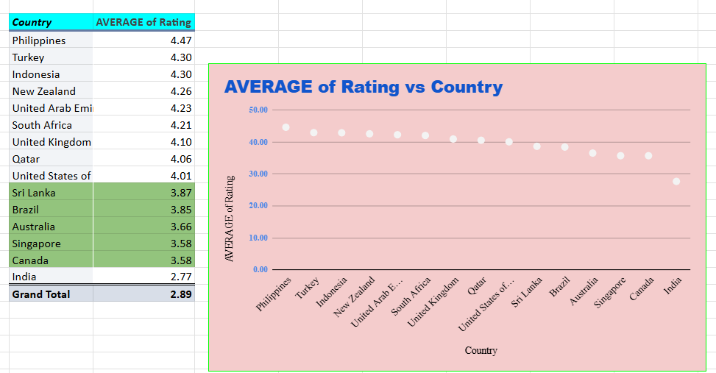

- Visualization Technique : ‘Scatter Chart’
Image From ‘Subjective Q - 1’ Worksheet in Excel Sheet
Recommendations:
- Market Research: Conduct a comprehensive qualitative analysis in the top three recommended countries to determine the underlying reasons for their low average ratings.
- Concept Development: Develop a restaurant concept specifically tailored to address the identified customer pain points and market gaps.
- Small-Scale Entry: Launch a pilot outlet on a smaller scale in the capital city of the leading target country to reduce initial investment risk and enable real-time improvements based on customer feedback.

Question – 2 Come up with the names of States and cities in the suggested countries suitable for opening restaurants.
Answer :
Analysis and Approach:
• To suggest suitable cities within the recommended countries, a detailed city-level analysis was conducted.
• The same methodology was applied by creating a Pivot Table, focusing on the average rating for each city. Additionally, the “Has Online Delivery” field was included in the values section to evaluate the availability of online delivery services.

- Visualization Technique : ‘Stacked Bar Chart’

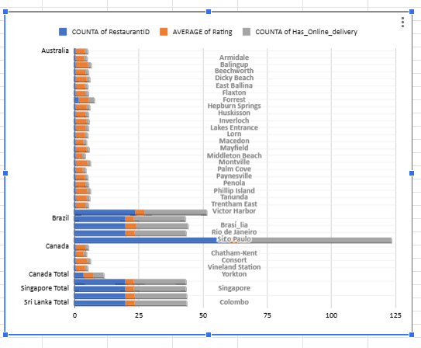
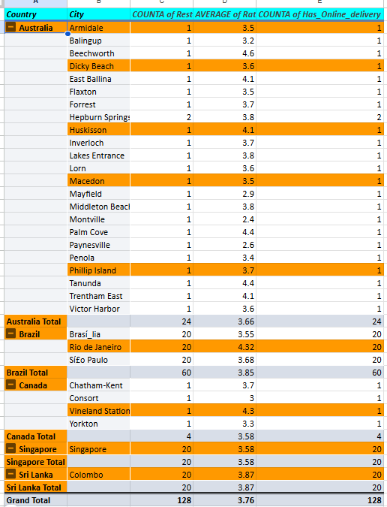

Image From ‘Subjective Q - 2’ Worksheet in Excel Sheet

Insights:
• Based on your earlier shortlisted countries — Australia, Canada, Sri Lanka, Singapore, and Brazil — here are insights on suitable states and cities for opening new restaurants, considering high restaurant density, strong average ratings (above 3.5), urban population, tourism, and online delivery presence.
• Here are deeper strategic insights for the shortlisted countries — focusing on consumer behavior, competition level, pricing strategy, cuisine opportunities, risk factors, and expansion potential.
Suggested Cities:
According to analysis suggested cities are: a) Armidale, Dicky, Beach, Huskisson, Macedon, Philip Island from Australia.
b) Vineland station from Canada.
c) Singapore from Singapore.
d) Colombo from Sri Lanka.
e) Rio de Janeiro from Brazil.

Recommendations
1. Australia: Emphasize Quality in Regional & Tourist Destinations
Market Insight:
Regional and coastal towns attract tourists and higher-income residents who prefer quality dining experiences over basic options.
Recommendation:
- Coastal/Tourist Locations – Dicky Beach, Huskisson, Phillip Island
Establish a high-quality casual dining restaurant with a strong local identity. Target tourists and affluent locals seeking above-average dining experiences.
- Regional/Inland Areas – Armidale, Macedon
Develop an all-day café concept that transitions into a quality dinner service. Focus on efficient service to cater to students, professionals, and the local workforce.

2. Canada (Vineland Station, Ontario): Capitalize on Agri-Tourism
Market Insight:
Vineland Station is situated in the renowned Niagara wine region, attracting food and wine enthusiasts year-round.
Revised Recommendation:
Launch a farm-to-table or artisanal dining concept that emphasizes locally sourced ingredients. Strengthen branding through a strong digital and online presence to position the restaurant as a higher-rated premium alternative to existing competitors.

3. Singapore: Adopt a Cloud Kitchen Strategy for Cost Efficiency
Market Insight:
Singapore is a highly competitive and expensive market with a mature food delivery ecosystem.
Revised Recommendation:
Implement a cloud kitchen or delivery-only model focusing on a niche cuisine (e.g., specialized regional Asian dishes or health-focused meals). This strategy minimizes high rental and labor costs while leveraging Singapore’s strong digital food ordering culture.

4. Sri Lanka (Colombo): Target the Expanding Urban Middle Class
Market Insight:
Colombo is experiencing growth in demand for international and fusion cuisine, particularly among young urban professionals.
Revised Recommendation:
Establish a full-service, mid-to-high-end international restaurant with seamless digital integration (online reservations, delivery, social media engagement). Improve upon the “low average rating” trend by delivering superior service quality, ambiance, and consistent food standards.

5. Brazil (Rio de Janeiro): Strengthen the Digital & Delivery Experience
Market Insight:
Rio de Janeiro has a rapidly expanding food delivery market. Low average ratings suggest that many restaurants struggle with maintaining quality in delivery operations.
Revised Recommendation:
Develop a high-volume, operationally optimized QSR or casual dining concept specifically designed for delivery efficiency. Consider a ghost kitchen or small-footprint outlet in a densely populated area to maximize delivery coverage and maintain quality control.

Question – 3 According to the countries you suggested, what is the current quality regarding ratings for restaurants that are open there?

Answer :

Approach:
- To address this question, I adopted the Pivot Table method once again.
- The average rating was considered as the primary evaluation factor.
- In the worksheet titled ‘Subjective Q - 2’, I placed Country in the Rows field and Average of Rating in the Values field (set to Average) to analyze country-wise performance.

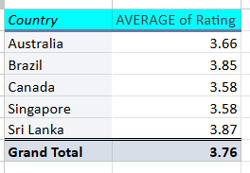

Image From ‘Subjective Q - 2’ Worksheet in Excel Sheet

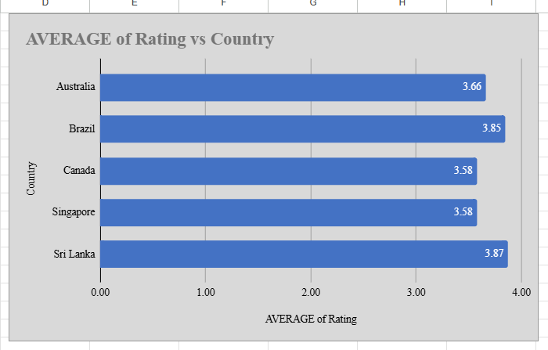

- Visualization Technique : ‘Horizontal Bar Chart’

Insights:
• All selected countries have average ratings between 3.5 and 3.8. • Sri Lanka has the highest average rating (3.8). • Canada and Singapore have the lowest average rating (3.5). • The variation in ratings is very small, indicating consistent restaurant quality across countries. • Overall, all countries show good restaurant standards, as ratings are close to 4.
ctp-etxy-gmw

Recommendation:
By placing Country in the Rows field and Average Rating in the Values field (set to Average), the following observations were identified:
- All the selected countries show average ratings within the range of 3.5 to 3.9.
- Sri Lanka records the highest average rating at 3.8, while Canada and Singapore share the lowest average rating at 3.5.
- Despite minor differences, all countries demonstrate a positive performance trend, as ratings between 3.5 and 3.8 generally indicate good overall restaurant quality.
- Sri Lanka’s leading rating suggests a market with well-established establishments, possibly upscale dining options, or strong customer satisfaction levels.
- Although Singapore reflects the lowest rating among the group, a score of 3.5 remains competitive by global standards.
- This may indicate that while Singapore maintains high-quality dining overall, minor inconsistencies in service or food delivery could slightly influence customer satisfaction.
- The limited variation in ratings across countries highlights that each market has a fundamentally strong restaurant sector, with only marginal scope for improvement in specific areas.

Question – 4 Also, what is the current expenditure on food in the suggested countries, so we can keep our financial expenditure in control?
Answer :
- Approach :
- To calculate the current expenditure and maintain financial control, I applied the Pivot Table method.
- In the worksheet titled ‘Subjective Q - 2’, I placed Country in the Rows field and included Average Cost for Two (in INR) along with Count of Restaurants in the Values field for analysis.
Expenditure Analysis:
- For better clarity, I created a separate summary table specifically for the suggested countries.
- The estimated total expenditure was calculated by multiplying the Average Cost for Two by the Total Number of Restaurants in each country.
- This approach provides a clear comparison of overall spending levels across the selected markets.

- Analysis of expenditure being calculated :

For better clarity, I prepared a separate table for the suggested countries showing the estimated expenditure, calculated by multiplying the Average Cost for Two by the total number of restaurants in each country.
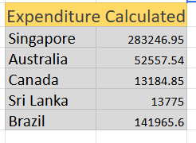

Used ‘Pie Chart’ for clear view for expenditure comparisons between suggested countries which is shown below:

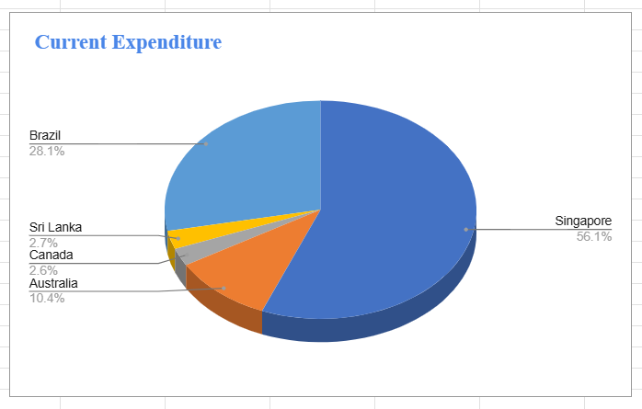
Observation:
- Singapore records the highest food expenditure at approximately ₹2.8 lakh, contributing the largest share of the total spending.
- In comparison, Sri Lanka, Brazil, and Canada account for a much smaller portion, highlighting a substantial expenditure gap among the selected countries.

Key Insights
1. Significant Spending Disparity
- Singapore dominates the overall food budget due to its higher average dining costs, greater number of recommended restaurants, and premium market conditions.
2. Financial Sensitivity Concentration
- Budgetary decisions in Singapore have a major impact on total expenditure, whereas financial changes in Sri Lanka, Brazil, or Canada have comparatively minimal influence, making them lower-risk markets from a cost perspective.
3. Value & Market Efficiency Indicator
- Sri Lanka, Brazil, and Canada offer relatively cost-effective dining opportunities, enabling more restaurant coverage per rupee spent and potentially delivering stronger return on investment (ROI).

For Visualization purpose I am mentioning pivot table and Combo of Bar and line chart of count of restaurants vs average cost of two in INR .

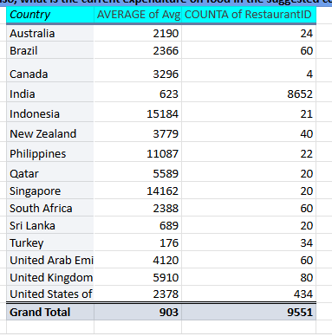

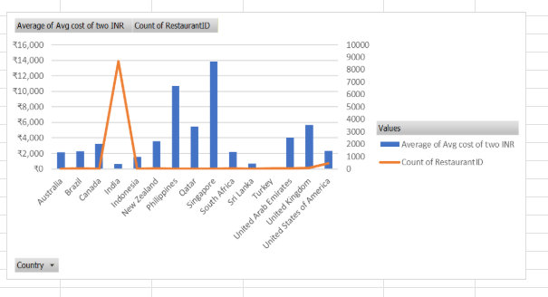

Visualization technique : ‘Combo Chart of Bar and Line Chart’
Image From ‘Subjective Question 2’ Worksheet in Excel Sheet.
Recommendations :-
To maintain effective control over total financial expenditure—particularly by regulating the higher costs in Singapore—the following strategic recommendations are essential:

1. Budget Reallocation and Cost Control
- Singapore Priority Management: Reduce the two primary cost drivers in Singapore—the average meal price and the number of restaurant reviews.
- Allocate a larger portion of the overall budget to Singapore due to its higher market costs, but implement a strict spending ceiling.
- Assign relatively smaller budgets to Sri Lanka, Brazil, and Canada, as their financial impact on the total budget is comparatively low.

2. Strategic Dining Approach in Singapore
- opt for Cost-Effective Options: Focus on affordable dining choices such as hawker centers and local eateries to reduce the overall average cost per meal.
- Limit high-end or premium restaurant reviews to only those that are strategically important for the project objectives.

3. Rebalancing Project Emphasis
- Expand Reviews in Lower-Cost Markets: Increase the number of restaurant reviews in Sri Lanka, Brazil, and Canada to generate greater content volume while maintaining lower overall costs.
- This approach helps offset Singapore’s higher expenditure and improves overall cost efficiency without compromising project scope.

Question - 5 Come up with the names of restaurants from the recommended states that are our biggest competitors and also those that are rated in the lower brackets, i.e. 1-2 or 2-3.
Answer :-
Approach:
- Applied the Pivot Table method to analyses this question.
- Included Country and Restaurant Name in the Rows field, and used Average Rating and Average Votes in the Values field within the Excel worksheet titled ‘Competitors and Low Rated Rest.’
Based on this analysis, competitors were evaluated using the Pivot Table, as illustrated below.
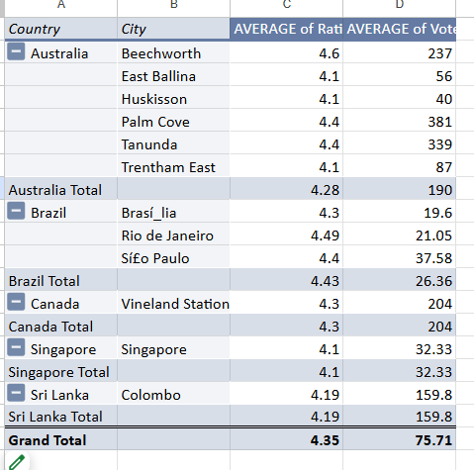
Image From ‘Competitors and Low Rated Rest’ Worksheet in Excel Sheet
Insights on Available Competitors
The analysis identifies several high-performing restaurants across Canada, Sri Lanka, and Australia. These establishments maintain ratings above 4 and demonstrate strong customer engagement.
Key Competitors Identified
• Australia:
- Beechworth, East Ballina, and Huskisson and Palm Cove have emerged as strong competitors in the Australian market. These restaurants consistently achieve high customer satisfaction levels and receive substantial positive feedback, establishing clear benchmarks for quality and service standards.
• Canada:
- Vineland Station, stands out as a leading competitor, supported by strong ratings and a significant number of votes. This reflects its popularity and solid reputation within its region.
• Sri Lanka:
- The Commons and The Sizzle are notable competitors, demonstrating both high ratings and considerable customer engagement. Their performance positions them as key reference points for service quality and customer satisfaction in Sri Lanka.
Overall, these restaurants reflect strong customer approval and market presence, making them important benchmarks for evaluating service excellence and competitive positioning within their respective regions.
Insights about restaurants rated in lower bracket
According to pivot table shown I summarized low bracket rated restaurants
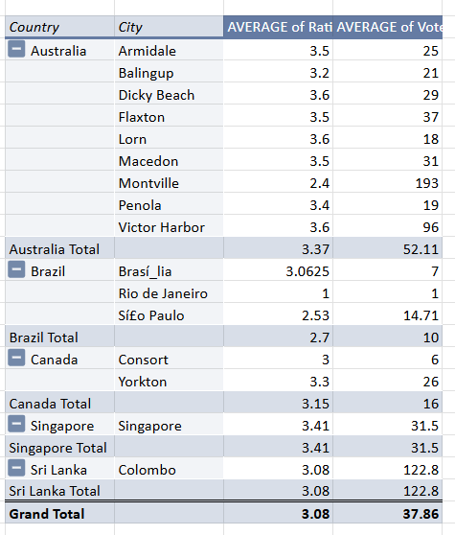

Key Insights from the Data
1️⃣ 🇦🇺 Australia – Strong Stability with High Engagement
- Average Rating: 3.37 (above overall average of 3.08)
- Average Votes: 52.11 (highest among all countries)
- Cities like Victor Harbor (96 votes) and Montville (193 votes) show strong engagement.
- Ratings are mostly between 3.2 – 3.6, indicating consistent customer satisfaction.
Insight: Australia is a mature and stable market with good customer trust and participation.

2️⃣ 🇸🇬 Singapore – High Quality, Moderate Volume
- Average Rating: 3.41 (highest overall)
- Average Votes: 31.5
- Only one city listed, but performance is strong.
Insight: Singapore delivers the best quality perception among all listed countries, though expansion data is limited.

3️⃣ 🇨🇦 Canada – Decent Quality, Low Market Penetration
- Average Rating: 3.15
- Average Votes: 16 (low engagement)
Insight: Customer satisfaction is acceptable, but visibility and customer participation are low. This may indicate underdeveloped market presence.

4️⃣ 🇱🇰 Sri Lanka – High Engagement but Average Satisfaction
- Average Rating: 3.08
- Average Votes: 122.8 (very high engagement)
- Colombo shows strong customer interaction but moderate rating.
Insight: Customers are highly active, but satisfaction levels are just average. This suggests potential service quality gaps.

5️⃣ 🇧🇷 Brazil – Weakest Performing Market
- Average Rating: 2.7 (lowest)
- Average Votes: 10 (very low engagement)
- Rio de Janeiro has a rating of 1.0 (critical concern).
Insight: Brazil faces both low customer satisfaction and low engagement — a double risk market.

Question - 6 Which cuisines should we focus on in the newer restaurants to get better feedback? Does the choice of cuisines affect the restaurant ratings?
Answer :-
Approach :-
- To analyses the factors influencing cuisine preferences in emerging restaurants and their impact on customer feedback, I used a visual analytical approach.
- Visualization Technique: Line Chart created using a Pivot Table.
- In the Pivot Table (worksheet named ‘Cuisine Analysis’), I placed Country and Cuisine in the Rows section and used Average of Rating in the Values section to evaluate performance trends across different cuisines and countries.
Analysis and Insights:
Visualization Technique : Line Chart.
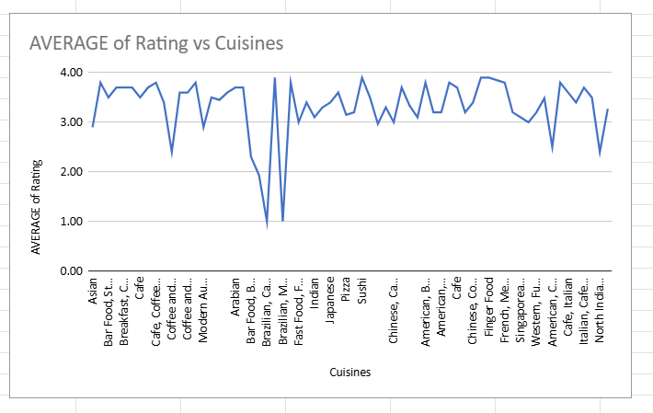
Image From ‘Cuisine analysis’ Worksheet in Excel Sheet

- A review of the chart indicates clear cuisine preferences across different countries.
- In Australia, the most popular dining options include Pizza, Bar Food, Mediterranean cuisine, and Modern Australian Breakfast.
- Respondents in Canada show a strong preference for Japanese and Sushi, Chinese, and Italian cuisines.
- In Singapore, Bakery items, American Steak, and Continental dishes are particularly well received.
- Brazil primarily reflects popularity for traditional Brazilian cuisine.
- Individuals in Sri Lanka demonstrate a notable inclination toward Seafood, Juices, and Desserts.
- According to our data top 10 cuisine is also evaluated for better insight below:
- Visual Technique used: ‘Column Chart’
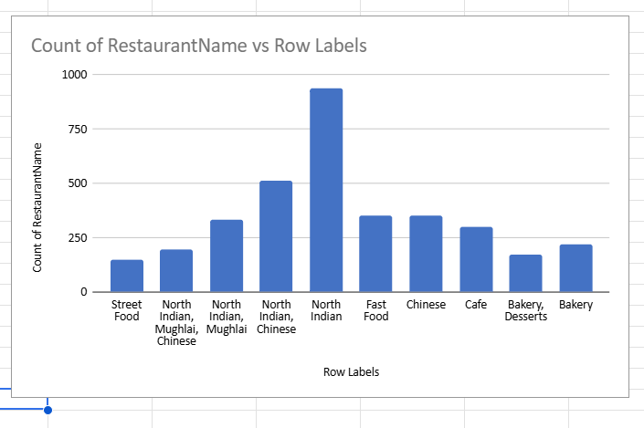
Recommendations:
- Link Between Ratings and Cuisine Type: Restaurant ratings show a strong association with the type of cuisine offered, indicating that customer satisfaction is significantly influenced by food preferences.
- Menu Planning for New Restaurants: New establishments should focus on offering popular local and high-demand dishes to align with customer expectations and encourage favorable reviews.
- Adapting to Emerging Trends: Incorporating contemporary food trends, such as plant-based or farm-to-table options, can help attract a broader and more diverse customer base.

Question – 7 According to our current data, should we go for online delivery and table booking? Does that affect the customer’s ratings?

Answer :- Approach:
- I examined whether online delivery and table booking facilities are available in the countries suggested for expansion.
- For this assessment, I created a separate table in the worksheet titled ‘Online Booking Analysis’.
- The evaluation was conducted by considering the Country, Has Online Delivery, and Has Table Booking columns.
- The analysis revealed that none of the selected expansion countries currently offer online delivery or online table booking facilities.

Table is shown below:
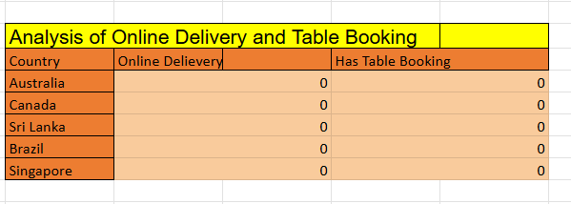
Image From ‘Online booking analysis’ Worksheet in Excel Sheet
Applied formulas:
=COUNTIFS('Raw Data'!N:N,"Yes",'Raw Data'!D:D,"Australia")
(for Australia - Online Delivery)
=COUNTIFS('Raw Data'!M:M,"Yes",'Raw Data'!D:D,"Australia")
(for Australia - Table Booking)
Similar formulas are used for both criteria in the other four countries.

Analysis :
- Visualisation technique used: ‘Pie Chart’
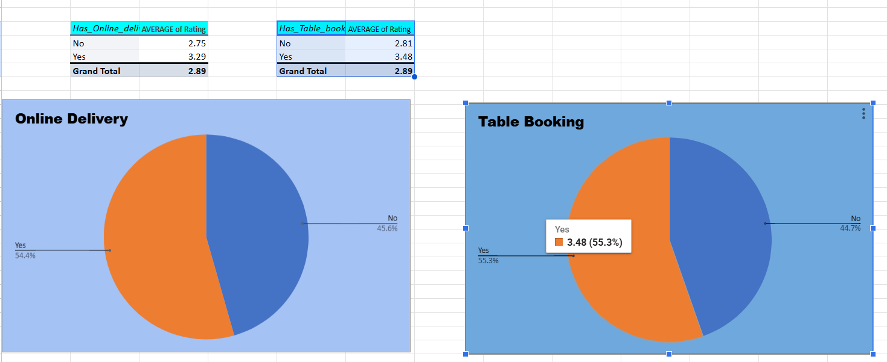
Approach:
- Pivot Tables were used to compare the average ratings of restaurants offering online delivery and table booking services, in order to assess the impact of these facilities.
- The fields ‘Has Table Booking’ and ‘Has Online Delivery’ were placed in the Rows section, while Average of Rating was used in the Values section.
- Two separate Pivot Tables were created to calculate the average ratings individually, ensuring a clearer and more accurate comparison.

Rephrased Insights:
- Countries that offer online delivery and table booking services generally experience higher average ratings and a greater number of votes.
- These markets not only achieve better customer satisfaction scores but also demonstrate stronger customer engagement.
- The overall analysis indicates that the availability of online services positively influences restaurant ratings.

Rephrased Suggestions:
- Introducing online delivery and table booking facilities in the identified countries could create a strong competitive advantage.
- Many local restaurants in these markets currently lack such digital services, presenting an opportunity for differentiation.
- Before implementation, it is essential to evaluate pricing strategies, service feasibility, and customers’ willingness to pay for added convenience.
Question – 8 Should the team keep the rate of cuisines higher? Will that affect the feedback? According to our data are the rates of cuisines and ratings, correlated?

Answer :-
Approach:
- Created a Pivot Table titled “Correlation between Cuisine and Rating” in the Excel worksheet.
- Applied filters to include only the recommended countries for analysis.
- Added Cuisine Type as the Row field to compare different categories.
- Computed the Average Rating and Average Cost for Two (in INR) for each cuisine type.
- Displayed both calculated averages in the Values section of the Pivot Table.
- Developed a Scatter Chart to visually represent the relationship between restaurant ratings and associated costs.
Additionally, I used the CORREL function:
=CORREL(C4:C1828,D4:D1828)
This allowed me to determine the correlation between cuisine ratings and average costs for two people in INR shown below:
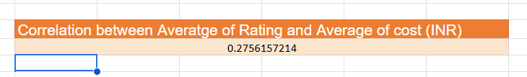
Insights :
- Visualization technique used: ‘Scatter Plot’
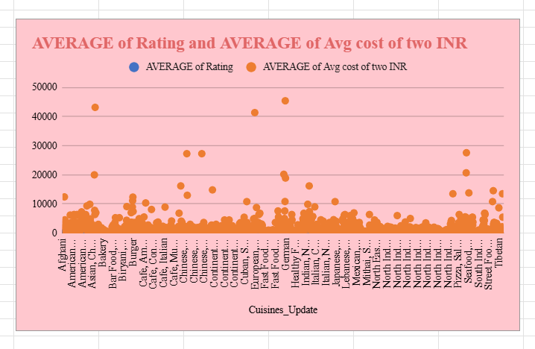
Recommendations:-
The analysis indicates a clear positive relationship between cuisine ratings and the average cost for two people. In general, higher-rated cuisines tend to be priced higher.

1. Maintain a Balance Between Cost and Quality
- Adopt Strategic Pricing: Since higher ratings are associated with higher costs, premium cuisines should be priced appropriately to reflect superior ingredients, preparation techniques, and dining experience. This ensures alignment with customer expectations while covering operational expenses.
- Emphasize Value for Money: For mid-range or budget-friendly options, focus on delivering strong quality relative to price. Maintaining a high value-to-cost ratio can help secure competitive ratings even at lower price levels.

2. Position High-Cost Cuisines as Premium Offerings
- Leverage Highly Rated Options: High-rated and high-priced cuisines can be strategically positioned as premium offerings. These attract customers who are willing to pay more for superior quality and experience, potentially enhancing overall customer satisfaction and brand perception.

3. Analyze Low-Cost, High-Rating Exceptions
- Replicate Success Factors: Identify cuisines that achieve high ratings despite comparatively lower costs. These represent strong value propositions. Studying their sourcing methods, preparation efficiency, or menu positioning can provide insights that may be applied across other offerings.

4. Ensure Pricing Transparency
- Align Price with Experience: Any price increase should be clearly justified through noticeable improvements in quality, portion size, presentation, or service. Transparency helps manage customer expectations and supports positive feedback, especially since customers appear willing to pay more for better quality.
Question – 9 What is the distribution of the number of restaurants of different price ranges in all the countries?
Answer:-
Approach:
- To analyses the above question, I created a Pivot Table by placing Countries in the Rows section and Price Range in the Columns section for comparative evaluation.
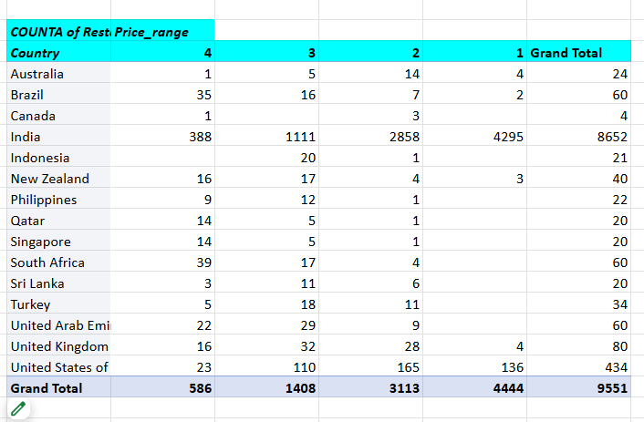

Insights:
Distribution of Restaurants by Price Range Across Countries
- India dominates the dataset as the largest market, with over 85% of restaurants concentrated in the lower to mid-price segments (Price Ranges 1 and 2). This indicates a strong consumer preference for affordable dining options.
- In contrast, the United States, United Arab Emirates, and South Africa display a more balanced distribution across price categories, with a noticeable concentration in Ranges 2 and 3. This suggests a preference for a blend of budget-friendly and mid-tier dining experiences.
- Countries such as Australia, the United Kingdom, Singapore, and Canada have a higher proportion of mid-to-premium restaurants (Price Ranges 3 and 4) compared to budget options. This may reflect stronger purchasing power or a greater demand for upscale dining.
- Lastly, markets like Qatar, Turkey, and Indonesia are represented by only a limited number of restaurants in the dataset. Most of these fall within higher price segments, potentially indicating niche markets or untapped growth opportunities.

- Visualization Technique used: ‘3 D column Full Stack Chart’

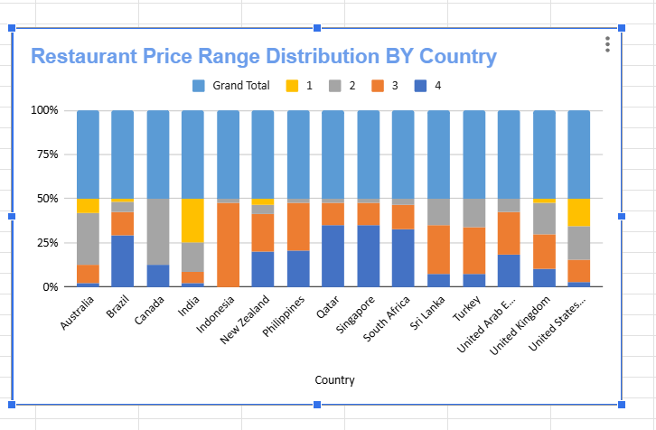
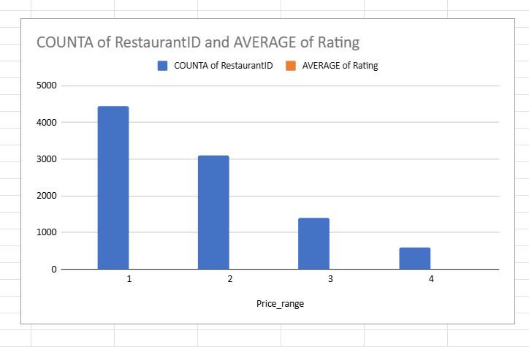
- Visualization Technique: ‘Combo Chart of Bar and Line Chart’
Suggestions:
- In India and Brazil, Zomato can strengthen its presence by focusing on budget-conscious consumers. This could include introducing combo offers, loyalty programmers, easy-to-use affordability filters, and price-driven promotional campaigns to attract value-seeking customers.
- In markets such as the United States, United Arab Emirates, the United Kingdom, and Australia, the strategy could emphasise premium positioning. This may involve highlighting high-quality listings with curated tags, promoting chef’s specials, and offering premium memberships that include reservation benefits and exclusive deals.
- In emerging or less-penetrated markets like Indonesia, Qatar, and Sri Lanka, Zomato could adopt a phased approach by initiating local pilots, forming partnerships with selected restaurants, and testing pricing models to identify the most effective expansion strategy.
Question – 10 Explain your approach in brief for suggesting countries/cities in order to open new restaurants, if the objective and subjective questions would have not been given to assist you.
Answer:- Approach for Identifying Suggested Countries and Cities for Restaurant Expansion
To identify the most appropriate countries and cities for launching new restaurants, a structured methodology was applied using key performance indicators and market potential metrics:

Selection of Countries
- Assessed countries based on average restaurant ratings, particularly prioritizing those with ratings above 4.0 to ensure strong customer satisfaction levels.
- Identified countries with a relatively low number of existing restaurants, highlighting potential market gaps and expansion opportunities.
- Analyzed average vote counts, giving importance to countries with higher customer engagement, as this reflects active demand and market interest.

Identification of Suitable Cities
- Within the shortlisted countries, cities were evaluated individually to determine their expansion potential.
- Prioritized cities with a higher average cost for two, as these markets offer stronger revenue-generating potential.
- Selected cities with fewer existing restaurants, reducing competition and increasing the likelihood of successful entry.
- Ensured that shortlisted cities maintain an above-average restaurant rating (greater than 3.5), indicating a positive dining environment and customer satisfaction.

Cuisine Analysis
- Examined popular cuisines in the selected cities to understand local food preferences and emerging trends.
- Focused on cuisines that combine high ratings with a higher average cost for two, aligning with revenue growth objectives.
- Prioritized cuisines already in strong demand, as established popularity supports faster market penetration and customer acquisition.

